**Assignment 3**

*// 1.  Reverse a Number (Hint : % , *)*

**public** **class** Reverse{

**public** **static** **void** main(String[] args) {

**int** num=1234;

**int** sum=0;

        while(num!=0){

          sum=(sum*10)+(num%10);

          num/=10;

        }

        System.out.println(sum);

    }

}

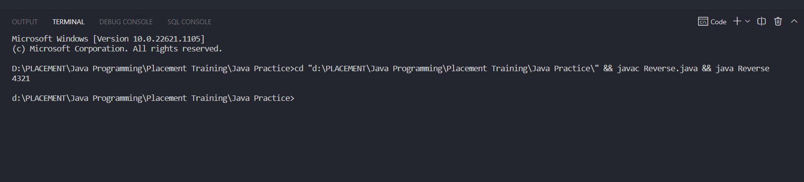

*// 2.  Sum of Digit (Sum of Even Places and Odd Places) and Print Both of Them*

**public** **class** Even_Odd {

**public** **static** **void** main(String[] args) {

**int** evensum=0;

**int** oddsum=0;

**int** num=1234;

**boolean** flag=true;

    while(num!=0){

        if(flag){

            evensum+=num%10;

            flag=false;

        }

        else{

            oddsum+=num%10;

            flag=true;

        }

        num/=10;

    }

    System.out.println("Even placed sum="+evensum);

    System.out.println("Odd placed sum="+oddsum);

 }

}

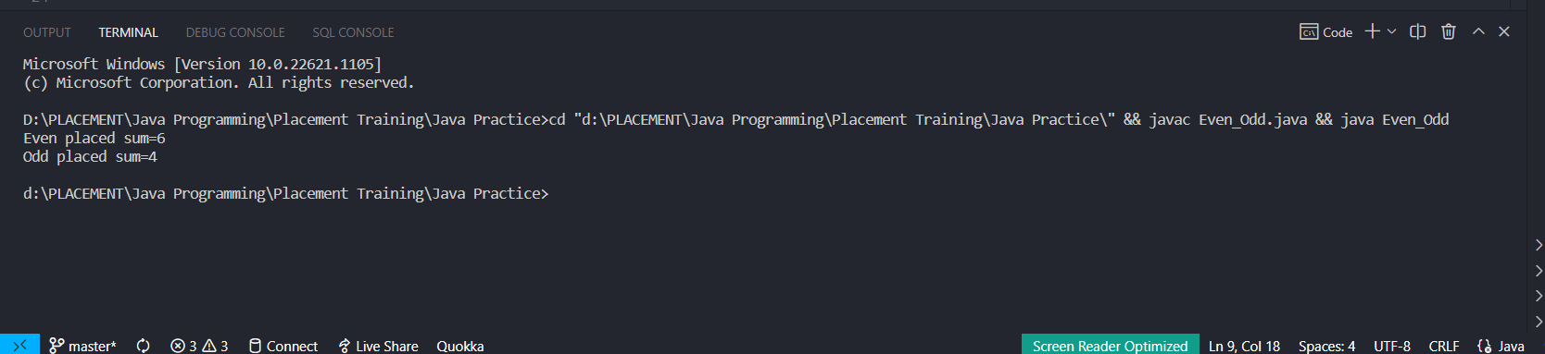

*// 3.LCM of a Number*

**public** **class** Lcm {

**public** **static** **void** main(String[] args) {

**int** a=20,b=40;

**int** gcd=1;

*// Finding the greatest common divisor*

            for (**int** i = 1; i <=a && i<=b; i++) {

                if(a%i==0 && b%i==0)

                gcd=i;

            }

*// LCM*GCD=a*b*

            System.out.println("Lcm is-:"+(a*b)/gcd);

   }

}

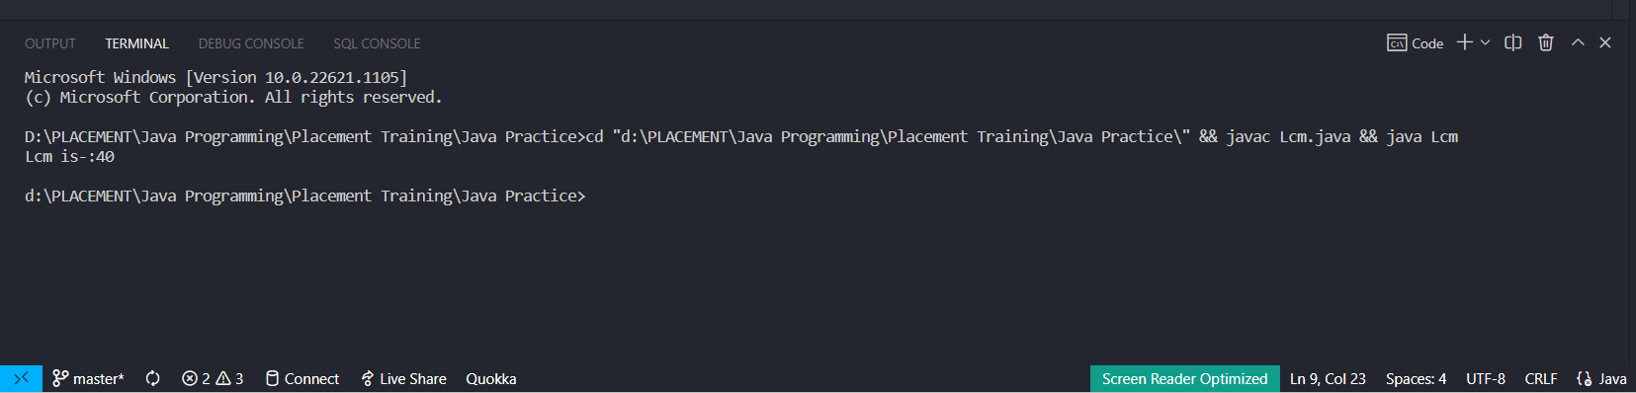

*// 4. ArmStrong Number e.g 153 1 ^3 + 5 ^ 3 + 3 ^3 = 153*

**public** **class** ArmstrongNumber {

**public** **static** **void** main(String[] args) {

**int** num=153;

**int** dub=num;

**int** rep=num;

**int** count=0;

**int** sum=0;

        while(dub!=0){

            count++;

            dub/=10;

        }

        while(num!=0)

        {

            sum+=Math.pow(num%10, count);

            num/=10;

        }

        if(sum==rep)

        System.out.println("Armstrong Number");

        else

        System.out.println("Not a Armstrong Number");

    }

}

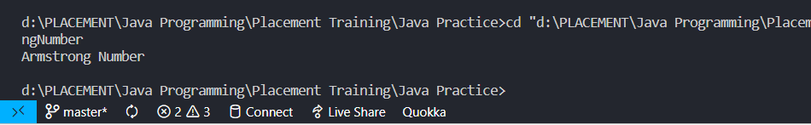

*// 5.Sum of Series 1 + 1/2 + 1/3 + 1/4 + 1/5*

**public** **class** SeriesSum {

**public** **static** **void** main(String[] args) {

**double** sum=0;

for (**int** i = 1; i <= 5; i++) {

    sum+=(1/i);

}

System.out.println("Sum is-:"+sum);

    }

}

